**Lagrange’s Interpolation:**

*By :- Asit Joshi(CS-45)*

*Date :- May 8, 2022*

In many real world applications of science and engineering, it is required to find the value of dependent variable corresponding to some value of independent variable by analyzing data which are obtained from some observation.

Interpolation is a method of finding new data points within the range of a discrete set of known data points. In other words interpolation is the technique to estimate the value of a mathematical function, for any intermediate value of the independent variable.   
For example, in the given table we’re given 4 set of discrete data points, for an unknown function f(x) :

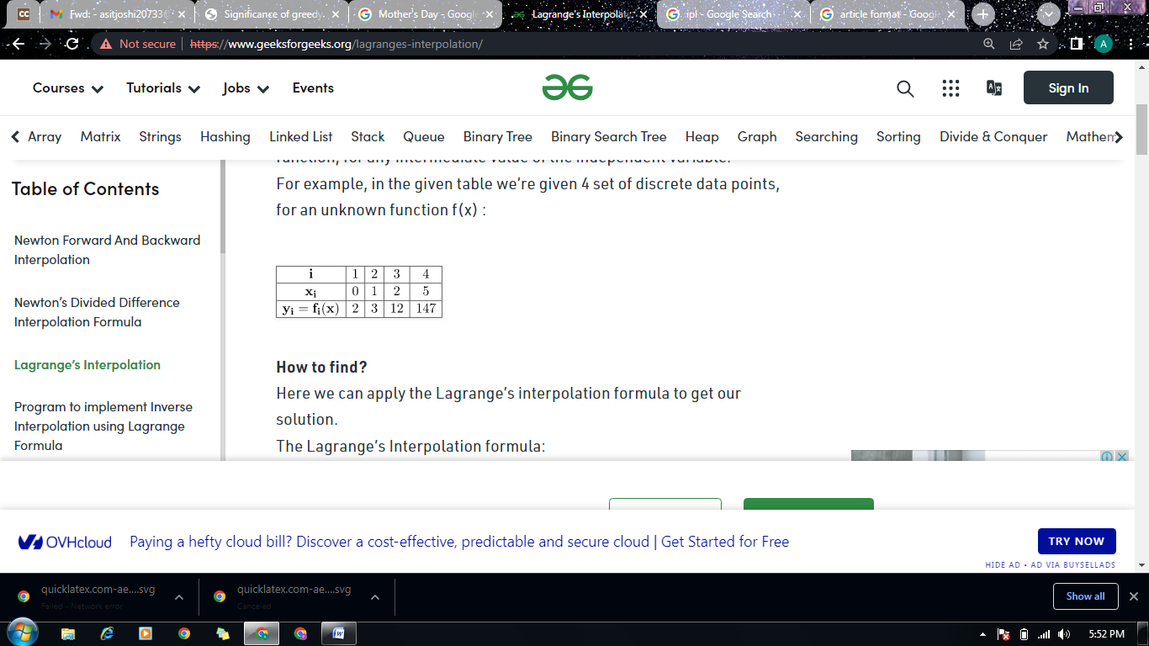

Then the method of finding the value of y = f(x) corresponding to any value of x=xi within x0 and xn is called **Interpolation**. Thus interpolation is the process of finding the value of function for any intermediate value of the independent variable. If we need to estimate the value of function f(x) outside the tabular values then the process is called **Extrapolation**. However, in general, extrapolation is also included in interpolation.

There are different methods for interpolation for example: Newton’s Forward Interpolation, Newton’s Backward Interpolation, Newton’s General Interpolation with divided difference, Lagrange Interpolation etc. In this article we are going to develop **an algorithm for Lagrange Interpolation.**

If y = f(x) takes the value of y0 , y1 , y2 , y3 , ... , yn corresponding to x0 , x1 , x2 , x3 , ... , xn then

y = f(x) = (x - x1)(x - x2)...(x - xn) * y0/(x0 - x1)(x0 - x2)...(x0 - xn)

+

(x - x0)(x - x2)...(x - xn) * y1/(x1 - x0)(x1 - x2)...(x1 - xn)

+ .... +

(x - x1)(x - x2)...(x - xn-1) * yn/(xn - x0)(xn - x1)...(xn - xn-1)

is known as **Lagrange Interpolation Formula**for unequal intervals and is very simple to implement on computer.

**Advantages of Lagrange Interpolation:**

* This formula is used to find the value of the function even when the arguments are not equally spaced.
* This formula is used to find the value of independent variable x corresponding to a given value of a function.

**Disadvantages of Lagrange Interpolation:**

* A change of degreein Lagrangian polynomial involves a completely new computation of all the terms.
* For a polynomial of high degree, the formula involves a large number of multiplications which make the process quite slow.
* In the Lagrange Interpolation, the degree of polynomial is chosen at the outset. So it is difficult to find the degree of approximating polynomial which is suitable for given set of tabulated points.

**Algorithm: Lagrange Interpolation Method**

1. Start

2. Read number of data (n)

3. Read data Xi and Yi for i=1 ton n

4. Read value of independent variables say xp

whose corresponding value of dependent say yp is to be determined.

5. Initialize: yp = 0

6. For i = 1 to n

Set p = 1

For j =1 to n

If i ≠ j then

Calculate p = p * (xp - Xj)/(Xi - Xj)

End If

Next j

Calculate yp = yp + p * Yi

Next i

6. Display value of yp as interpolated value.

7. Stop

**Code for Lagrange’s Interpolation Method**

#include<bits/stdc++.h>

using namespace std;

struct Data

{

int x, y;

};

double interpolate(Data f[], int xi, int n)

{

double result = 0; // Initialize result

for (int i=0; i<n; i++)

{

double term = f[i].y;

for (int j=0;j<n;j++)

{

if (j!=i)

term = term*(xi - f[j].x)/double(f[i].x - f[j].x);

}

result += term;

}

return result;

}

int main()

{

Data f[] = {{0,2}, {1,3}, {2,12}, {5,147}};

cout << "Value of f(3) is : " << interpolate(f, 3, 5);

return 0;

}

Output :

